Project Name: Evaluating the Impact of Smart Irrigation Systems on Water Conservation and Crop Yield in Bangladesh: A Five-Year Analysis (2018-2022)

Asif Aman Jihad

**Background:** To tackle the biggest problem of Bangladesh agriculture water scarcity smart irrigation system was introduced. Over five years period from 2018-2022, these systems play a vital role to conserve water and increase crop manufacturing. This study assesses the impact of smart irrigation technologies, focusing on aspects as water conservation, crop yield enhancements and the integration of renewable energy.

**Methods:** Using quantitative data analysis with case studies of major initiatives and programs the study showcases the results. The effectiveness of smart irrigation systems is analyzed using data from government and NGO activities. The main indicators include the total number of smart irrigation systems deployed, the volume of water saved, the gains in crop yields, the amount of funding allocated, and the level of renewable energy incorporated.









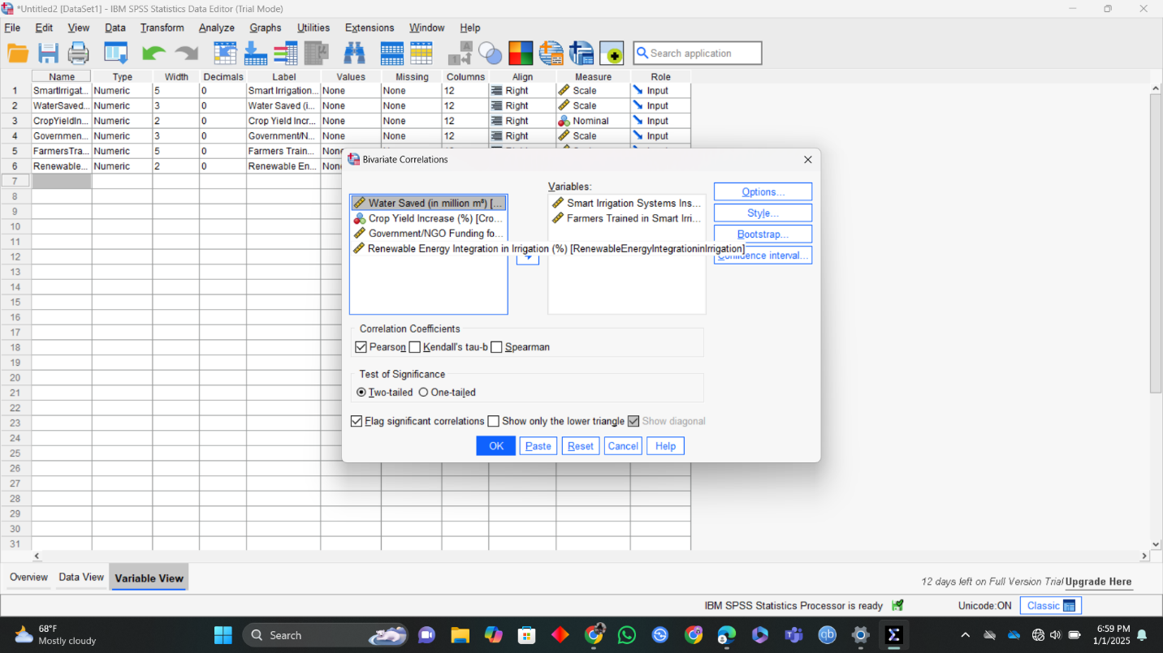





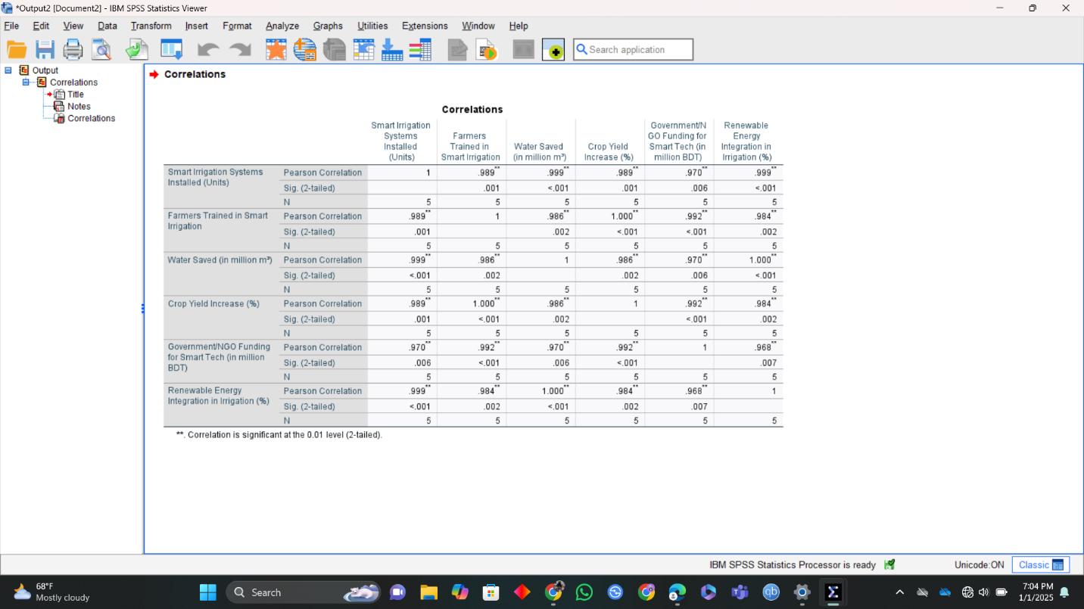

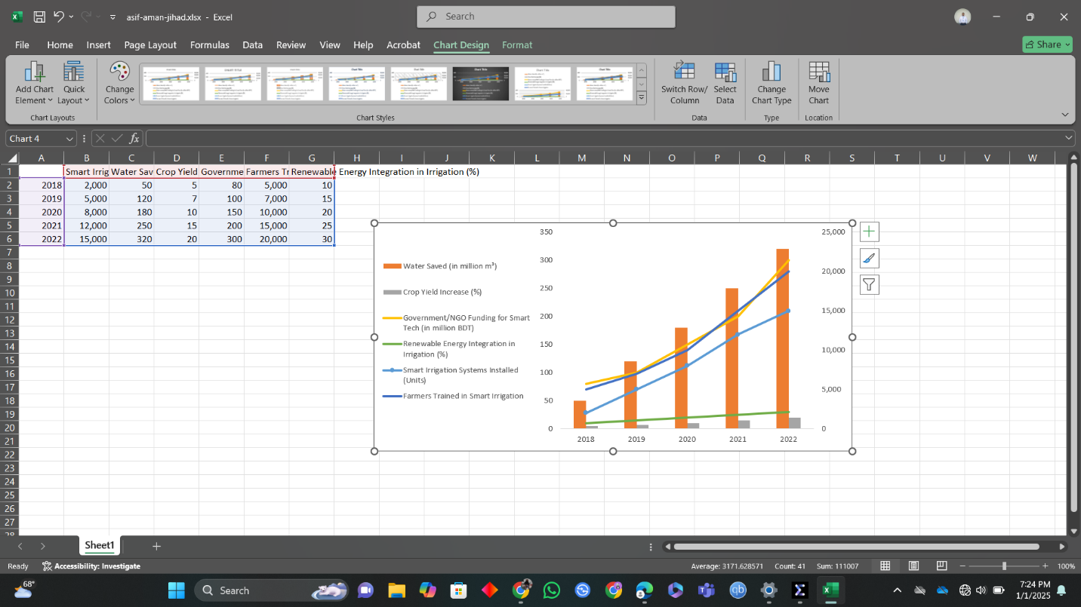

**Results:** The findings indicate a significant increase in the adoption of smart irrigation systems, leading to substantial water savings and notable improvements in crop yields. The integration of renewable energy sources, such as solar-powered irrigation, has also enhanced the sustainability of these systems. Despite these successes, challenges such as the need for high-quality training for farmers and addressing regulatory barriers remain.

**Conclusion:** Smart irrigation systems have proven to be a valuable tool in promoting sustainable agriculture in Bangladesh. The integration of these technologies has not only improved water management and crop productivity but has also paved the way for more environmentally friendly farming practices. Continued support and investment in these technologies are essential to overcome existing challenges and further enhance their benefits.